Project Design Phase
Problem – Solution Fit Template

Date | 28 June 2026
Team ID | Not Given
Project Name | Rising Waters
Maximum Marks | 2 Marks

Team Members | Skill Wallet Team ID’s | Roll Numbers (College: ACET)
Mohana Deepika Kancherla (Team Leader) | SWUID2026226898 | 23MH1A0596
Flora Disowja Sarugolu | SWUID2026212008 | 24P35A0549
Santhi Illa | SWUID2026212021 | 24P35A0550
Mathan Bhavesh Hari Raghava Krishna Munaga | SWUID2026212007 | 24P35A0532
Problem – Solution Fit Template:
The Rising Waters project addresses the challenge of inaccurate and delayed flood forecasting by using machine learning to analyze historical weather data. It provides timely and reliable flood risk predictions through a Flask web application, enabling authorities to make informed decisions, improve disaster preparedness, and reduce the impact of floods on communities.
Purpose:
- Provide accurate and timely flood predictions using machine learning to support early warning systems and reduce the impact of floods.
- Enable disaster management authorities and meteorologists to make faster, data-driven decisions for evacuation planning and emergency response.
- Improve disaster preparedness by analyzing historical weather data and identifying potential flood risks before they occur.
- Deliver an easy-to-use web application that allows users to input weather parameters and instantly receive flood risk predictions.
- Enhance public safety and resource allocation by helping authorities prioritize high-risk areas and deploy emergency resources efficiently.
- Support scalable cloud deployment through IBM Cloud, making the flood prediction system accessible, reliable, and available from any location.

Template:
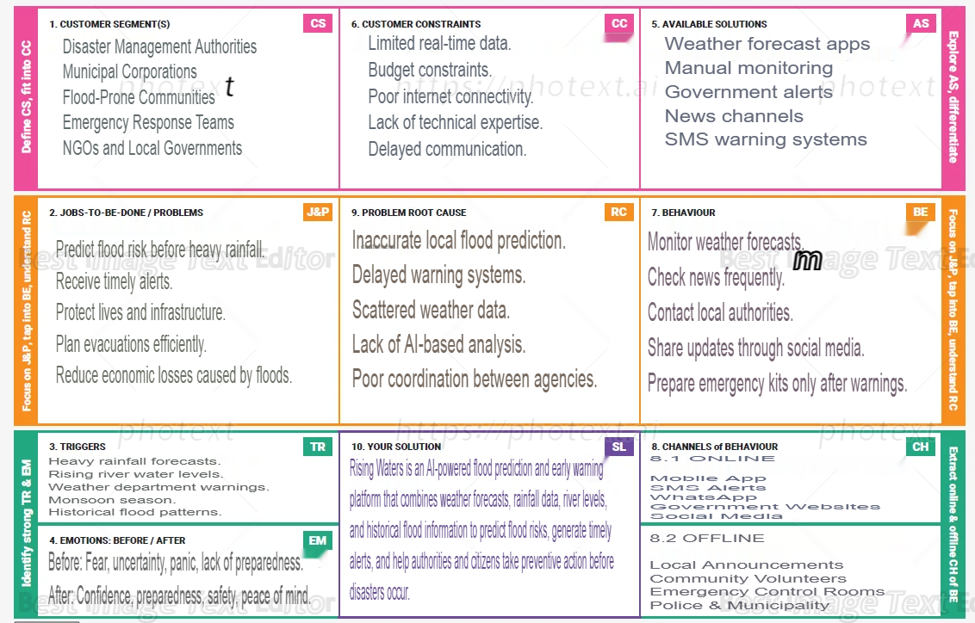
References:
- https://www.ideahackers.network/problem-solution-fit-canvas/
- https://medium.com/@epicantus/problem-solution-fit-canvas-aa3dd59cb4fe

